Award the paper bid in Georgia Procurement Registry(GPR)
Step # | Action
1 | Login to GPR. Link: https://ssl.doas.state.ga.us/PRSapp/PR_login.jsp
2 | Once login, user will land to ‘Bids Needing State Purchasing Approval or Awarding by the Agency’ page.  This page will list all the paper bids with ‘Under Evaluation’ status.  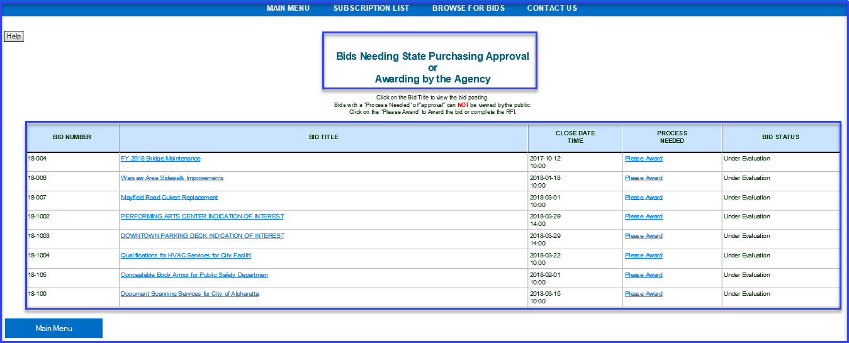
3 | Select the bid you want to award and click on ‘Please Award’ link for that bid.  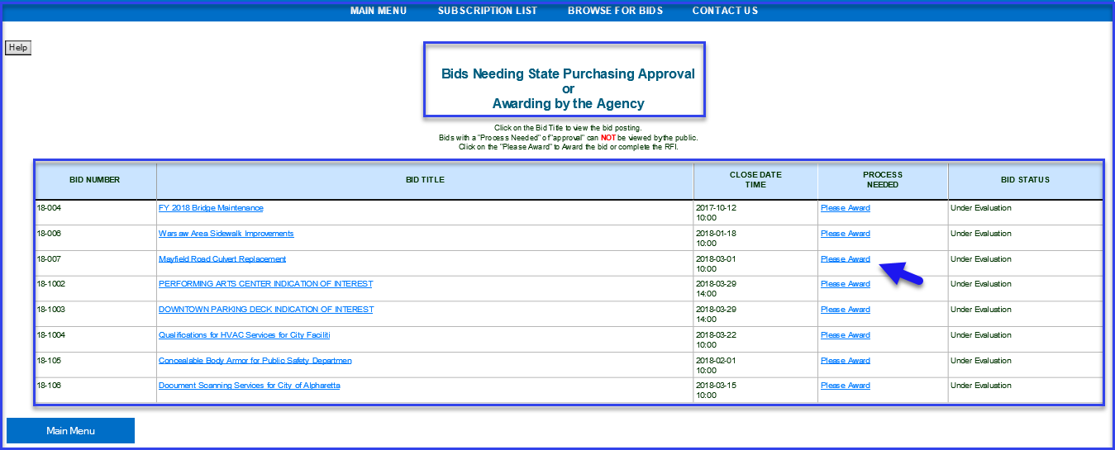
4 | Upload the Award Document or enter the Award information in the description box. Click on appropriate ‘Process…’ tab to proceed awarding the paper bid.  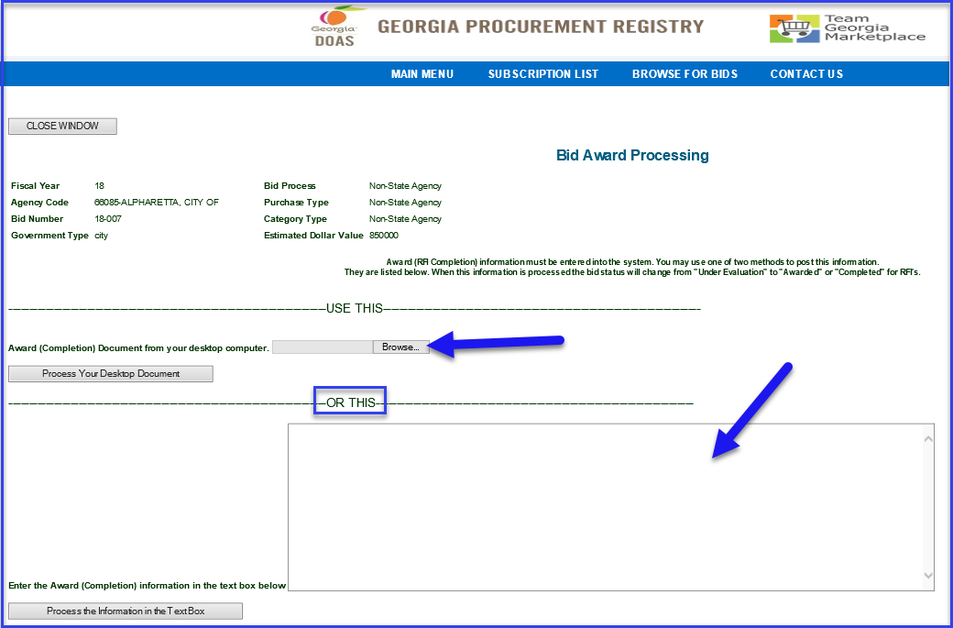
5 | Confirmation message of ‘The Bid Award has been processed’ will display on screen .  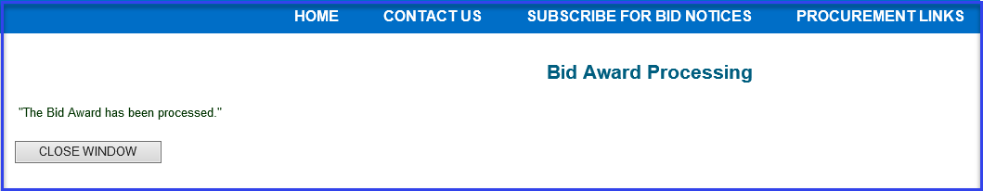
 | End

